NL EMMC ALPROSTADIL (Prostaglandin E1) DOSING FOR NEWBORNS

ALPROSTADIL 500 mcg/mL VIAL
FINAL DRIP CONCENTRATION 20 mcg/mL

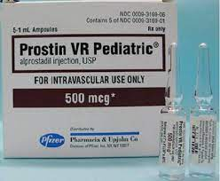

Medication | Final Concentration | Mixing Instructions
Alprostadil  500 mcg/mL vial | 20 mcg/mL | Less than 2 kg: Alprostadil 60 mcg=0.12 mL + 0.45% NaCl 2.88 mL  2 kg and greater: Alprostadil 500 mcg=1 mL + 0.45% NaCl 24 mL

- Usual initial rate: 0.05 mcg/kg/min
- Usual dose range 0.01-0.4 mcg/kg/min

NL EMMC NICU
207-275-1082

