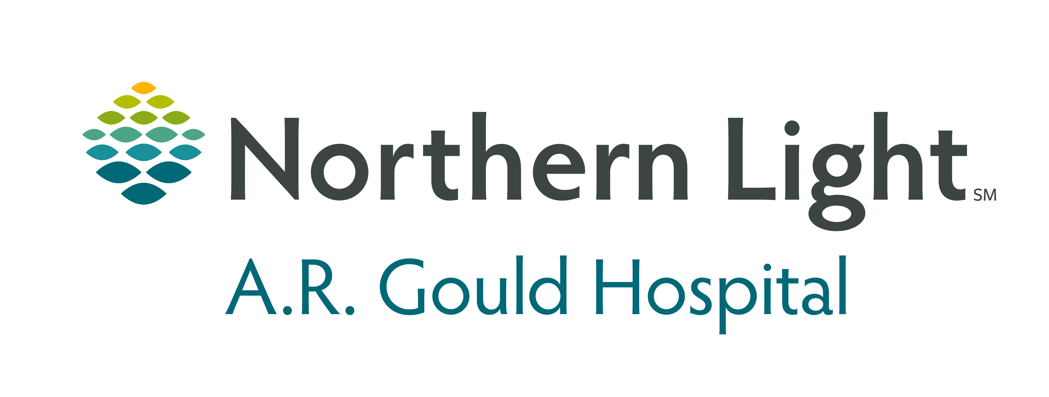

JOB SHADOW APPLICATION

NAME: AGE (if under 18) ___
ADDRESS:

HOME PHONE:
EMERGENCY CONTACT NAME____________________________

RELATIONSHIP__________________________

EMERGENCY CONTACT NUMBER_____________________________

E-MAIL ADDRESS:

IF STUDENT, NAME OF SCHOOL:

- Are you or have you previously been employed at NL-ARG or any other EMHS affiliate?

- Describe your career interest or interests?

- List the department(s) and / or staff you wish to observe.

- What do you hope to gain from this experience?

- If you have done any research concerning the career you desire to shadow, tell us about it.

- Have you applied to or been accepted to a college or university? If yes, where?

- Do you have any questions you would like addressed during your job shadow opportunity?

INFORMATION: Filling out this application is not a guarantee that your request can be honored. Department Manager approval must occur, and the offer may be withdrawn at anytime if it becomes inappropriate for patient care. JOB SHADOW applicants will be required to hear a review of basic life safety information and sign a CONFIDENTIALITY agreement. If you need to document and/or verify your job shadowing experience for high school or for college purposes, please bring the appropriate documentation for the Manager/Supervisor to sign upon completion of your job shadow experience. Questions may be directed to Dawn Roberts, 768-4248 or droberts@northernlight.org

Parent/Guardian Authorization is required for all students under 18 years of age

I understand that my child has requested a JOB SHADOW experience at NL-ARG. I understand that my child will be under strict obligations of confidentiality concerning any matters of patient care observed at NL-ARG. I also understand that my child will not be allowed to administer any level of patient care. This opportunity is one strictly of observation. I understand that I will be contacted if any emergency arises. S/he will be under the specific direction of an assigned NL-ARG employee for the duration of the job shadow experience.

Signed: _____Day Phone: ___Date:

JOB SHADOW AGREEMENT

I understand that I will be under the direction of a NL-ARG employee for the duration of my JOB SHADOW experience. I will be required to wear an authorized NL-ARG identification badge while at NL-ARG and I understand it is my responsibility to return the badge to the employee to whom I am assigned upon completion of my job shadow experience. I will come well groomed. Visible body piercing jewelry must be non-distracting and may be worn only (1) on the ears and (2) in the form of a single nose stud. Body art depicting nudity, profanity or violence must be covered. Personal cleanliness is essential. **Please dress in professional attire**

I understand that I will sign a CONFIDENTIALITY AGREEMENT to remind me to keep all matters of patient care and medical center business confidential. I agree to follow all directions given me by the employee to whom I am assigned.

Signed: Date:

Please mark one answer only:
_____ Release time from school is approved by:
(Name and title)
_____ The job shadow will take place outside of regular school hours.

SCHOOL RECOMMENDATION (student applicants only): Please write a brief recommendation from Guidance Counselor, Teacher, or School Administrator.

Applicant is: _____in good standing; _____ not in good standing with the school.

Signed: Title: Date:

JOB SHADOW
CONFIDENTIALITY AGREEMENT

The health, comfort and well being of patients are the primary concern of all at Northern Light AR Gould Hospital. Job Shadow participants must observe the following rules of conduct. They will also help you avoid unpleasant experiences and prevent criticism. Mature conduct by Job Shadow participants makes it possible to continue this program.

The first rule of medical center confidentiality for everyone including Job Shadow participants is protection of patients’ “right to privacy.” This means that all information about any patient’s stay at the medical center is confidential.

Job Shadow Participant Agreement:

I understand that my Job Shadow experience, patients’ names, or illnesses are NEVER to be mentioned to ANYONE inside or outside of the Hospital except to the staff member I am working with.

I understand that I should not read any paper or record relating to a patient unless specifically directed to by the employee with whom I am working. I will follow directions carefully.

I understand that I must NEVER discuss a patient with other patients or with friends or family. If I have questions, I will consult only the employee with whom I am working.

When I leave the medical center, I will leave behind all information I may have heard. If an experience bothers or puzzles me, I will talk it over with my assigned employee before I leave.

Students - If I am required to share about my experience in a class or writing assignment, I will remember not to discuss specific information about any individual patient. I may discuss my experience and my feelings about what I observed but will NEVER give enough detail for others to identify patients.

I agree to follow the CONDIFIDENTIALITY AGREEMENT and guidelines shared with me. I understand that I may be withdrawn from participation at anytime by the employee to whom I am assigned or the Human Resources Department if in their sole discretion they determine it to be in the best interest of NL-ARG or its patients.

Signed: Date:
Job Shadow Participant

Print Name:
Job Shadow Participant
Job Shadow Agreement Form

Northern Light AR Gould Hospital is pleased to provide you with a shadow experience in our health care system. We are excited that you are considering a career in the health care field. This agreement is to ensure that you comply with the Employee Health and Infection Prevention guidelines at Northern Light AR Gould Hospital.

It is important to understand that this experience offers you the opportunity to observe a member of our health care staff performing an occupation that interests you. During your time at Northern Light AR Gould Hospital, you will not be allowed to participate directly in-patient care activities, operate equipment, access patient records, or perform any other “hands on” functions.

To protect our patients as well and you the observer, it is imperative that you have the following health and immunization requirements prior to learning in one of our facilities. Guidelines are as follows.

- Seasonal Influenza vaccination is not required, but strongly recommended.

If you have any questions regarding these requirements please contact Dawn Roberts, 768-4248.

Please check yes or no for each of the following questions. If you check yes, please provide us with details.

Have you ever:
Yes No
Asthma ◻ ◻ _______________________
Epilepsy ◻ ◻ ___________________________________
Heart Trouble ◻ ◻ ____________________________________
Fainting ◻ ◻ _______________________

Other__________________________________________

By signing this form, I verify that I am compliant with the above guidelines and can produce necessary documentation upon request. I also agree that Northern Light AR Gould Hospital will not be liable for any illness or injury that I may incur during my observation experience.

X_____________________________________________________________________
Signature of Job Shadow Participant

X_____________________________________________________________________
Signature of Parent/Guardian if participant is under 18 years of age.

- Return Completed Forms to:
Dawn Roberts, LPN, Community Health, and Volunteer Coordinator
droberts@northernlight.org
(207) 768-4248
PO Box 151
Presque Isle, Me. 04769

